NAME : KALPANA SINGH
📄 MILESTONE 1 REPORT
Project Title: CliniScan – Lung Abnormality Detection Using AI
Internship: Infosys Springboard
Environment: Kaggle Notebooks with GPU

1. Introduction
The objective of Milestone 1 was to acquire and prepare the VinBigData Chest X-ray dataset, establish the development environment, and create initial data preprocessing pipelines required for object detection modeling. This milestone focused on building a clean and structured dataset suitable for YOLO-based training.

2. Dataset Acquisition
The VinBigData Chest X-ray Abnormalities Detection dataset was accessed through Kaggle competitions.
Dataset Details:
- Total Files: 18,002
- Format: DICOM images (.dicom)
- Annotation File: train.csv
- Annotation Type: Bounding boxes with class labels
- Total Size (raw dataset): ~205 GB (mounted in Kaggle input directory)
The dataset was successfully mounted using:
/kaggle/input/competitions/vinbigdata-chest-xray-abnormalities-detection
Dataset accessibility was verified by:
- Listing directory contents
- Loading sample DICOM files
- Visualizing sample X-ray images

3. Development Environment Setup
The development environment was configured in Kaggle Notebook with the following stack:
Libraries Used:
- PyTorch pydicom pandas
- NumPy
- OpenCV
- tqdm (progress monitoring)
GPU availability was verified, and required directories were created in:
/kaggle/working/
Environment validation included:
- Import testing of required libraries
- Reading DICOM files
- Displaying X-ray images
STEP 1 : SETTING ENVIRONMENT
INPUT :
import numpy as np # linear algebra
import pandas as pd # data processing, CSV file I/O (e.g. pd.read_csv)

# Input data files are available in the read-only "../input/" directory
# For example, running this (by clicking run or pressing Shift+Enter) will list all files under the input directory

import os
for dirname, _, filenames in os.walk('/kaggle/input'):
for filename in filenames:
print(os.path.join(dirname, filename))
OUTPUT : /kaggle/input/competitions/vinbigdata-chest-xray-abnormalities-detection/sample_submission.csv
/kaggle/input/competitions/vinbigdata-chest-xray-abnormalities-detection/train.csv
/kaggle/input/competitions/vinbigdata-chest-xray-abnormalities-detection/test/83caa8a85e03606cf57e49147d7ac569.dicom
/kaggle/input/competitions/vinbigdata-chest-xray-abnormalities-detection/test/7550347fa2bb96c2354a3716dfa3a69c.dicom
/kaggle/input/competitions/vinbigdata-chest-xray-abnormalities-detection/test/74b23792db329cff5843e36efb8aa65a.dicom……

4. DICOM to JPG Conversion
Since deep learning models require standard image formats, all DICOM images were converted to JPG format.
Conversion Process:
- Read DICOM using pydicom
- Extract pixel array
- Normalize pixel values to range 0–255
- Resize images to 1024 × 1024
- Save as compressed JPG (quality=85)
Reason for Using JPG:
- PNG was storage-intensive
- JPG reduced storage by ~5–8×
- Total storage after conversion: ~3.8 GB
All ~15,000 training images were successfully converted and saved in:
/kaggle/working/images/train
INPUT CODE: import os
import pydicom
import cv2
import numpy as np
from tqdm import tqdm

# ===== PATHS =====
TRAIN_DICOM_PATH = "/kaggle/input/competitions/vinbigdata-chest-xray-abnormalities-detection/train"
IMAGE_SAVE_PATH = "/kaggle/working/images/train"

# Create output folder if not exists
os.makedirs(IMAGE_SAVE_PATH, exist_ok=True)

# Get all DICOM file names
image_files = [f for f in os.listdir(TRAIN_DICOM_PATH) if f.endswith(".dicom")]

print(f"Total images found: {len(image_files)}")

# ===== CONVERSION LOOP =====
for idx, file_name in enumerate(tqdm(image_files)):

image_id = file_name.replace(".dicom", "")
dicom_path = os.path.join(TRAIN_DICOM_PATH, file_name)
save_path = os.path.join(IMAGE_SAVE_PATH, image_id + ".jpg")

# Skip if already converted (safe re-run)
if os.path.exists(save_path):
continue

try:
dicom = pydicom.dcmread(dicom_path)
image = dicom.pixel_array.astype(np.float32)

# Normalize to 0–255
image = (image - image.min()) / (image.max() - image.min() + 1e-6)
image = (image * 255).astype(np.uint8)

# Resize (optional but recommended for training speed)
image = cv2.resize(image, (1024, 1024))

# Save as compressed JPG (storage safe)
cv2.imwrite(save_path, image, [cv2.IMWRITE_JPEG_QUALITY, 85])

# Progress log every 2000 images
if (idx + 1) % 2000 == 0:
print(f"{idx + 1} images processed...")

except Exception as e:
print(f"Error processing {image_id}: {e}")

print("✅ DICOM → JPG conversion completed.")

OUTPUT :
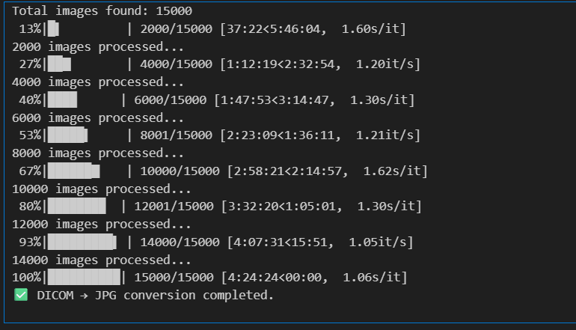
5. Annotation Cleaning
The dataset contained a special class:
class_id = 14 → "No Finding"
Since object detection models require bounding boxes for abnormalities, all entries with class_id = 14 were removed.
After filtering:
- Remaining bounding box annotations: 36,096
- Only abnormal findings retained
This ensured that the dataset was suitable for detection training.
INPUT :
# ===== MASTER PATH CONFIG =====
BASE_PATH = "/kaggle/input/competitions/vinbigdata-chest-xray-abnormalities-detection"

TRAIN_DICOM_PATH = BASE_PATH + "/train"
CSV_PATH = BASE_PATH + "/train.csv"

IMAGE_SAVE_PATH = "/kaggle/working/images/train"
LABEL_SAVE_PATH = "/kaggle/working/labels/train"

import os
os.makedirs(IMAGE_SAVE_PATH, exist_ok=True)
os.makedirs(LABEL_SAVE_PATH, exist_ok=True)

print("Paths configured successfully ✅")
import pandas as pd

df = pd.read_csv(CSV_PATH)

# Remove "No finding"
df = df[df["class_id"] != 14]

print("Remaining annotations:", len(df))
df.head()

OUTPUT :
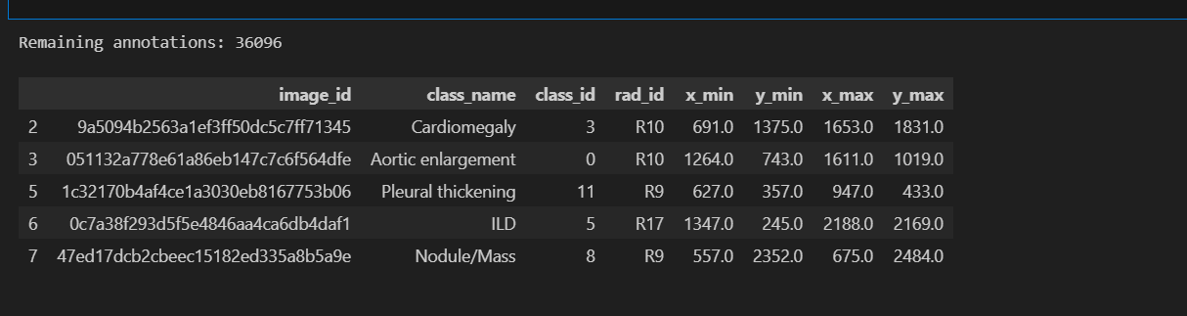

6. CSV to YOLO Annotation Conversion
Bounding box annotations from train.csv were converted into YOLO format.
Original Format:
x_min, y_min, x_max, y_max
Converted YOLO Format:
class_id x_center y_center width height
Where:
- Coordinates were normalized by image width and height
- One .txt file created per image
All label files were saved in:
/kaggle/working/labels/train
INPUT
import cv2
from tqdm import tqdm

grouped = df.groupby("image_id")

for image_id, group in tqdm(grouped):

img_path = IMAGE_SAVE_PATH + "/" + image_id + ".jpg"

if not os.path.exists(img_path):
continue

img = cv2.imread(img_path)
h, w, _ = img.shape

label_path = LABEL_SAVE_PATH + "/" + image_id + ".txt"

with open(label_path, "w") as f:
for _, row in group.iterrows():

class_id = int(row["class_id"])

x_min = row["x_min"]
y_min = row["y_min"]
x_max = row["x_max"]
y_max = row["y_max"]

x_center = ((x_min + x_max) / 2) / w
y_center = ((y_min + y_max) / 2) / h
box_width = (x_max - x_min) / w
box_height = (y_max - y_min) / h

f.write(f"{class_id} {x_center} {y_center} {box_width} {box_height}\n")

print("YOLO labels generated for full dataset ✅")
OUTPUT :
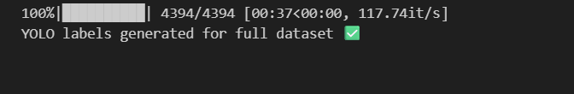

8. Final Dataset Structure
The final YOLO-ready dataset structure:
vinbig_yolo/
images/
train/*.jpg
labels/
train/*.txt
The dataset was compressed into:
vinbig_yolo_dataset.zip
Final compressed size: ~779 MB

9. Milestone 1 Evaluation Criteria Fulfilled
✔ Dataset successfully acquired and verified
✔ Development environment configured
✔ DICOM images converted to JPG
✔ “No Finding” class removed
✔ CSV annotations converted to YOLO format
✔ Dataset packaged for model training
Milestone 1 has been successfully completed.

10. Conclusion
Milestone 1 successfully established a structured and clean object detection dataset from raw DICOM medical images. The preprocessing pipeline ensures compatibility with YOLO-based models and sets a strong foundation for model development and training in Milestone 2.

LINK TO NOTEBOOK : https://www.kaggle.com/code/kalpana25/infosys-springboard

